1 | Name of the Institution | NMKRV College
 | Address of the Institution | 45/1,22nd Cross,Jayanagar 3rd Block,
 | City & Pincode | Bengaluru-560011
 | State | Karnataka
 | Phone Number | 080-69018904
 | Fax Number
 | Office Hours of the Institution | 10 A.M to 5.30 P.M
 | Academic Hours at the Institution | 7.30 Hrs
 | Website | www.nmkrv.edu.in
 | E-Mail | nmkrv@rvei.edu.in
 | Nearest railway station (distance in  kms) | 6.9 kms
 | Nearest Airport (distance in Kms) | 38.5 Kms
 | Type of institution | Private-Aided
2 | Name of the Organization running the Institution | Rashtreeya Sikshana Samithi Trust
 | Type of Organization | Trust
 | Address of organization
 | Registered with
 | Registration date
 | Website of the organization
3 | Name of Principal / Director | Dr.Suchithra R
 | Exact Designation | Principal
 | Phone number with STD code | 080-69018904
 | Email | principal.nmkrv@rvei.edu.in
 | Highest degree | Ph.D
 | Field of Specialization
4 | Name of the affiliating University | Bangalore University
 | Address | Jnanabharathi Campus,Mysore Road,
 |  | Bangalore-560056
 | Website | https://bangaloreuniversity.karnataka.gov.in/
 | Latest affiliation period | 2022-23 to 2026-27

5.Organizational Chart
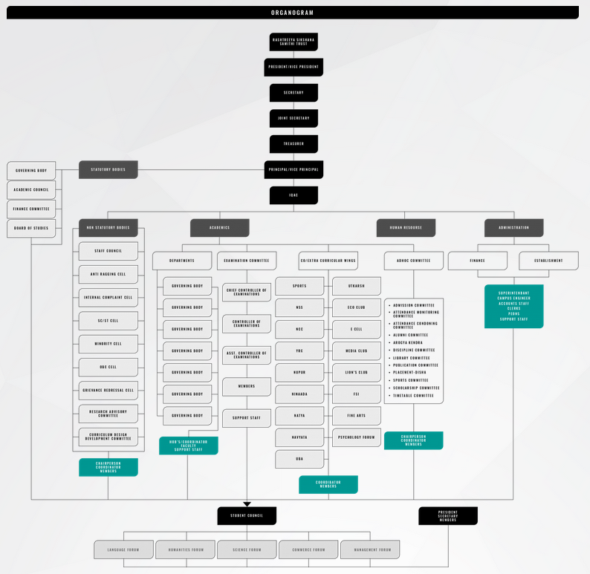

5.i | Governing Body Members
Sl.No | Name of the Members | Designation
1 | Ms.Maya Chandra | Chairperson
2 | Dr.(h.C) A.V.S Murthy | Member-Trustee
3 | Sri.P.S.Vankatesh Babu | Member-Trustee
4 | Sri.K.S.Akhilesh Babi | Member-Trustee
5 | Sri.D.P.Nagaraj | Member-Educationist
6 | Dr.Ramakrishna Reddy | Joint Director-Directorate of Collegiate Education
7 | Dr.Y Venkataramanappa | Member-Faculty
8 | Dr.Sangeetha G N | Member-Faculty
9 | Dr.Suchithra R | Ex-Officio
10 | Sri Syed Shahameer | Special Invite
11 |  | UGC Nominee
12 |  | University Nominee
13 | Dr.Sharadha T | Member-Secretary
14 | Wgcdr Shivanand | NMKRV Campus Director
5.i | Academic Council Members
Sl.No | Name of the Members | Designation
1 | Dr.R Suchithra | Chairperson
2 | Dr.(h.C) A.V.S Murthy | Member-Educationist
3 | Sri.Shravan Gupta | Member-Industry
4 | Dr.C S Prashanth | Member-Medicine
5 | Sri Sachin Shiva | Member-Commerce
6 | Dr.Somashekar | Bangalore University Nominee
7 | Dr.C Srinivas | Bangalore University Nominee
8 | Dr.K.Nirmala | Bangalore University Nominee
9 | Dr.Sharada T | Member-Secretary
10 | Mrs.Shilpa P | Member-COE
11 | Prof.Gunavathi V | Member-Faculty
12 | Smt.Manjula J | Member-Faculty
13 | Dr.Hamsha K | Member-Faculty
14 | Mrs.Priya R | Member-Faculty
15 | Mrs.Radhika D | Member-Librarian

 | 5.iii Establishment of Anti Ragging Cell
Sl.No | Name | Designation | Department | Mobile Number
1 | Dr.Suchithra R | Chairperson | Principal | 9980680442
2 | Anu Revamma Parvathi | Co-ordinator | Commerce | 8431875435
3 | Priya R | Member | Biotechnology | 9448309537
4 | Ashwini S | Member | History | 9071467982
5 | Sowmya B | Member | Sociology | 8892922131
6 | Sarala D | Member | Commerce | 9739244494

5.iv Establishment of Grievances and Redressal Committee (GRC):

Sl.No. | Name | Designation | Position
1 | Dr.Suman | Assistant Professor | Convenor
2 | Ms.Ashwini S | Assistant Professor | Co-Convenor
3 | Mrs.Bhamamani | Assistant Professor | Member
4 | Mrs.Sumana A S | Assistant Professor | Member
5 | Adv.Roopasri S | Advocate | External Member
5 | M/S S N Murthy Associates | Advocate | External Member
5.vi Establishment of Internal Complaints Committee (ICC):
Sl.No | Name | Profession | Department
1 | Dr.Suchithra R | CHAIR PERSON | Principal
2 | Suman N | MEMBER | Psychology
3 | Ms.Ashwini S | MEMBER | History
4 | Mrs.Bhamamani | MEMBER | Biotechnology
5 | Mrs.Sumana A S | MEMBER | Kannada
6 | Mrs. Padmavathi B | MEMBER | Office
7 | Ms. Pavithra | MEMBER | Exam Section
8 | Mr.Poorvak | STUDENT | BBA
9 | Ms.Saniya | STUDENT | BCA
10 | Mr.Prajwal | STUDENT | BBA

5.vii Establishment of Committee for SC/ST:

Sl.No | Name | Designation
1 | Mrs. Manjula J | Assistant Professor
2 | Mr.Basavaraj Amarappa | Assistant Professor
3 | Mrs. Geetha P | Assistant Professor
4 | .Mr Parameshwar Naik | Non Teaching

5.viii Internal Quality Assurance Cell
List of Committee Members
Chairman:
1.Dr. Suchithra R, Principal
Convener:
2.Dr. Sharadha, IQAC
Members:
3.Dr. Saba Tarannum
4.Mrs.Anu Revamma P
5.Dr. Megha Dhadoti
6.Dr. Mrunalini B R
7.Mrs.Sumana A S
8.Ms. Gowthami G
9.Mr. Pavan Kumar C S
10.Mrs.Sarala D
11.Ms. Suparna K
12.Mrs.Bhamamani

Minutes of the Meeting

A meeting was held on 06.08.2022 in conference room at 1:15 pm and following are the resolutions were made:
AGENDA:
- Review of academic calendar and instructions.
- Students and faculty time tables.
- Course materials.
- Modes of teaching.
- Course files and quality of Cos.
- Mentoring.
- Lab. manuals.
- Discussed about faculty feedback format on facilities. The following points were discussed in the meeting:
  - Discussed to add some technical activities in departmental academic calendar.
  - Suggested to prepare student and faculty time tables.
  - Instructed to prepare the course. Materials of their respective course.
  - Discussed to give interactive lecture methods such as video lectures, PPT's and industrial visits are adopted by faculty members.
  - Suggested the quality course file and quality course outcomes preparations.
  - Discussed the student mentoring system at department level focuses on all issues related to stay and growth of the individual student.
  - Discussed about the lab manuals to add few practical which are not mentioned in curriculum.
  - Discussed about online classes requirements and training about the webex app to faculty

Equal Opportunity Cell (EOC):

6. Programmes Approved by AICTE and Affiliated by Bangalore University:

Sl.No | Programme | Year of Starting | Intake
1 | BBA | 1994 | 90
2 | BCA | 2021 | 60

6(ii) Status of NBA Accreditation of the Course: Not Applicable

6.iii Status of Accreditation of the Course

Cycle I | Accredited by NAAC with CGPA of 85-90% on four-point scale with B++ Grade. Valid from 16.09.2003 to 15.09.2008.
Cycle II | Accredited by NAAC with CGPA of 3.02 on four-point scale with A Grade. Valid from 28.03.2010 to 27.03.2015
Cycle III | Accredited by NAAC with CGPA of 3.22 on four-point scale with A Grade. Valid from 15.11.2015 to 14.11.2020
Cycle IV | Accredited by NAAC with CGPA of 2.98 on four-point scale with B++ Grade. Valid from 17.05.2022 to 16.05.2027

6.ivTotal number of courses : 2 Courses
6.v
Sl.No | Name | No. of Seats | Duration | Cut off Marks
1 | BBA | 90 | 3 years | First cum first serve
2 | BCA | 60 | 3 years | First cum first serve

6.vi

Fee - Attached Approval Copy:
Sl.No | Name of the Course | Fees
1 | BBA | 62290 Per Annum
2 | BCA | 76000 Per Annum
Campus Placement in the last year with Minimum Salary, Maximum Salary and Average Salary:
Sl.No | Parameter | Value
1 | BBA | 4 lakhs

6.vii
Name and duration of Programme(s) having Twinning and Collaboration with Foreign University(s) and being run in the same Campus along with status of their AICTE approval. If there is Foreign Collaboration, give the following details: | Not applicable

7.Faculty Details:
Sl.No | Name of the Faculty | Department | Designation | Highest Qualification | Date Of Joining | Full Tme/ Part time
1 | Anupama M A | BBA | Assistant Professor | M.com | Aug 30, 2009 | Full Time
2 | Pooja V | BBA | Assistant Professor | MBA | Feb 19, 2024 | Full Time
3 | Sharada A | BBA | Assistant Professor | M.com | Aug 19, 2024 | Full Time
4 | Deepalakshmi R | BCA | Assistant Professor | M. Tech | Aug 9, 2021 | Full Time
5 | Bindhya M | BCA | Assistant Professor | M.Sc CS | Jan 1, 2018 | Full Time
6 | Roopashree A | BBA | Assistant Professor | MBA | Dec 3, 2012 | Full Time
7 | Vandana G P | BCA | Assistant Professor | MCA | Jun 24, 2022 | Full Time
8 | Haritha N | BCA | Assistant Professor | MCA | Oct 25, 2023 | Full Time
9 | Rochana G | BCA | Lecturer | M.Sc Data Science | Aug 14, 2024 | Full Time
10 | Aishwarya S | BCA | Lecturer | MCA | Sep 20, 2024 | Full Time
11 | Leelavathi P | Kannada | Assistant Professor | M.Phil Kannada | Jul 12, 2010 | Full Time
12 | Dr. Sandhya Hegde | Kannada | Assistant Professor | Kannada P.hd | Jul 8, 2019 | Full Time
13 | Urmi Datta | Hindi | Assistant Professor | MA Hindi | Mar 8, 2021 | Full Time
14 | Dr. Veena Devi R | English | Assistant Professor | English P.hd | Sep 9, 2022 | Full Time
15 | Sudha G | BCA | Assistant Professor | BE CS | Sep 1, 2004 | Full Time
16 | Vaishnavi K | BCA | Lecturer | MCA | Feb 15, 2024 | Full Time

8.Profile of Principal

01. | Name | Dr.R.Suchithra
02. | Date of Birth | 13/07/1977
03. | Unique ID | 8958
04. | Educational Qualification | MCA,Ph.D
05. | Work Experience | Teaching | Research | Industry | Others
05. | Work Experience | 23 | 10
06 | Area of Specialization | Cloud Computing
07. | Courses taught at Under Graduate and Post Graduate Level | Java Program, User Interface Design
08. | Research Guidance(No of students) | 17
09. | No. of Papers published in National/International/Journals/Conferences | 45
10. | Master (Completed/Ongoing) | Completed
11. | PhD.D (Completed/Ongoing) | Completed
12. | Projects Carried out | ICSSR – 2 projects
13. | Patents (Filed & Granted) | 3
14. | Technology Transfer
15 | Research Publications(No. of Papers published in National/International/Journals/Conferences) | 45
16. | No. of Books published with details ( Name of the book,Publisher with ISBN,year of publication,etc) | 03

9.Fee

- Number of Fee waivers granted with amount and name of the students: 6 students from both BBA and BCA amount Rs.70900.
- Number of scholarship offered by the Institution, duration and amount:
BBA - 8 students - Rs.157331
BCA - 21 students – Rs.455685

10.Admission

- Number of seats sanctioned with the year of approval
Sl.No | Course | Sanctioned Intake | Year of Approval
01. | BBA | 90 | 1994
02. | BCA | 60 | 2022

- Number of students admitted under various categories each year in the last three years

Number of Students admitted under various categories year 2023-2024

Course | SC | ST | C1 | 2A | 2B | 3A | 3B | GM | TOTAL
BBA | 07 | 03 | 03 | 15 | 38 | 09 | 04 | 13 | 92
BCA | 06 | 01 | 03 | 10 | 16 | 05 | 04 | 15 | 60

Number of Students admitted under various categories year 2024-2025

Course | SC | ST | C1 | 2A | 2B | 3A | 3B | GM | TOTAL
BBA | 13 | 01 | 03 | 14 | 26 | 04 | 05 | 06 | 72
BCA | 10 | 01 | 01 | 13 | 11 | 12 | 07 | 05 | 60

Number of Students admitted under various categories year 2025-2026

Course | SC | ST | C1 | 2A | 2B | 3A | 3B | GM | TOTAL
BBA | 15 |  | 02 | 17 | 38 | 08 | 04 | 09 | 93
BCA | 08 | 01 | 02 | 16 | 21 | 05 | 03 | 04 | 60

- Number of applications received during last year for admission under Management Quota and number admitted.

Sl.No | Course | Year | No. of applications received | No.Admitted
01 | BBA | 2024-25 | 78 | 72
02 | BBA | 2025-26 | 90 | 90
03 | BCA | 2024-25 | 75 | 60
04 | BCA | 2025-26 | 65 | 60

11.Admission Procedure

- Mention the admission test being followed, name and address of the Test Agency/State Admission Authority and its URL -- NA

- Calendar for admission against Management quota seats.-15.04.2025
- Last date of request for applications—15.05.2025
- Last date of submission of applications-30.05.2025
- Dates for announcing final results-01.06.2025
- Release of admission list-02.06.2025
- Date for acceptance by the candidate-03.06.2025
- Last date for closing of admission and starting of the Academic session-31.08.2025
- The waiting list shall be activated only on the expiry of date of main list
- The policy of refund of the Fee, in case of withdrawal, shall be clearly notified
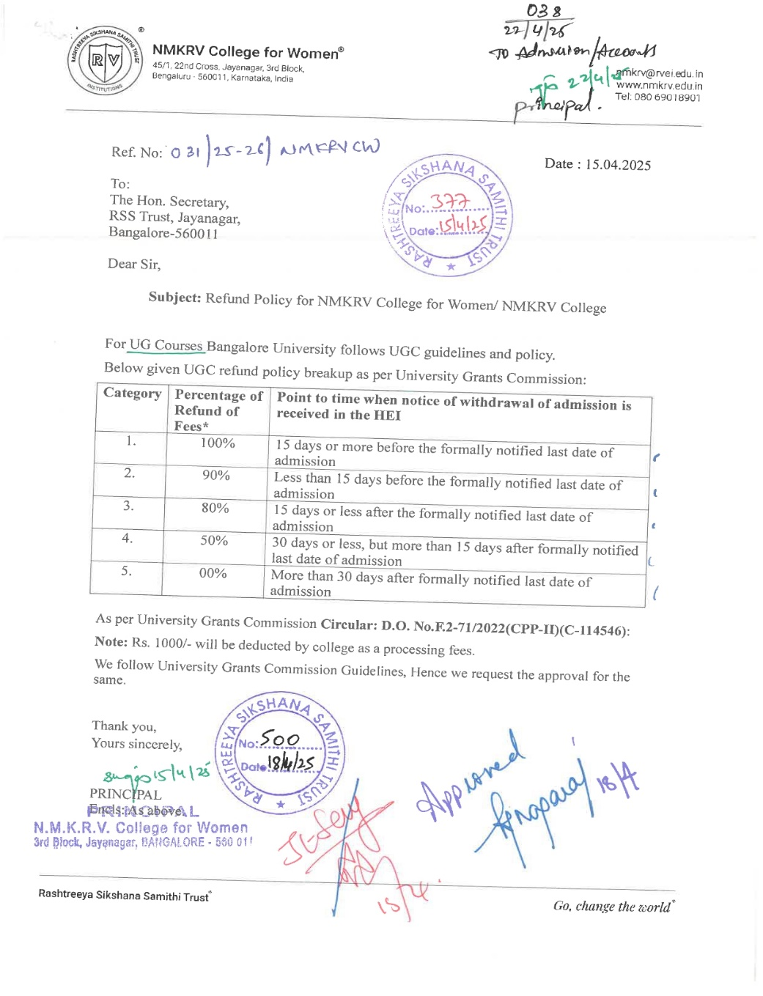

12.Criteria and Weight age for Admission
a. Admission Test: 50%
b. Marks in Qualifying Exam: 40%
c. Personal Interview (if applicable): 10%
Minimum Acceptance Level:
- General category: 50% in the qualifying exam
- SC/ST/OBC category: 45% in the qualifying exam

Cutoff Levels for Admission Test:
Minimum required percentage in the Admission Test: 60%
13.List of Applicants:
A list of candidates whose applications have been received, categorized separately for open seats, is as follows for the 2025 Batch:
• For the BCA course, there are 65 applicants
• For the BBA course, there are 90 applicants
15.Information of Infrastructure and Other Resources Available
Sl.No | Room No | Room Type | Carpet area in m2
01 | 101 | Classroom | 75
02 | 102 | Classroom | 80
03 | 103 | Classroom | 80
04 | 306 | Classroom | 75
05 | 307 | Classroom | 80
06 | 302 | Classroom | 75
02 | BBA Seminar Hall | Seminar Hall | 90

Number of Laboratories and size of each
Sl.No | Room No | Room Type | Carpet area in m2
01 | Lab1 | Computer Laboratory | 75
02 | Lab2 | Computer Laboratory | 75
03 | Lab3 | Computer Laboratory | 90
04 | Lab4 | Computer Laboratory | 75
05. | Lab5 | Computer Laboratory | 75
06 | Lab6 | Computer Laboratory | 40

15.v Central Examination Facility,Number of rooms and capacity of each
Area: 790 Sq/M, Dedicated Confidential Room, CCTV, Biometric enabled Doors to restrict unauthorized access. Dedicated systems and logins for Admins, Exclusive software portals for examination process and 24/7 security measure
Digital Evaluation system has been introduced. This has simplified the entire process of answer sheet evaluation. It includes many different features such as answer sheet evaluation. It includes many different features such as answer sheet scanning and storage, evaluation dashboard, analytic and reporting to measure performance. The scanning of physical answer sheets and their storage in digital format has helped in reducing the physical handling of answer sheets.
15.vi.Online examination facility (Number of Nodes,Internet bandwidth, etc)
----NA----
15.vii Barrier Free Built Environment for disabled and elderly persons
The following Infrastructure and other support measures are provided to persons with physical disabilities:
1. Ramps/Rails, Lifts, Special Toilets, Parking Lots, Scribes and assisting devises like Wheelchairs, walking-aids, hearing aids etc
2. Wheelchair users can move without others help. Provision of’ Ramps with minimum width of 1.5 Meters along with handrails at entrances, exits and passages.
3. Adequate space (1.2 Meters) is provided for movement of wheelchair users to enter into classrooms, laboratories, toilets and other areas within the building.
4. Ramp slope is l:12 for climbing by wheelchair users, even when they have a care giver, to push steep slopes can be painful.
5. Provision of lifts to Accommodate wheelchair users to move different floors.
6. Handrails for persons who use Crutches with anti-skid (non-slip) floors,
7. Accessible toilets with provision of handrails in urinals, wheelchair access to utilities like washbasin. Health facets, etc.
8. Reserved designated parking. Special Provisions for persons with Disabilities in the examination:
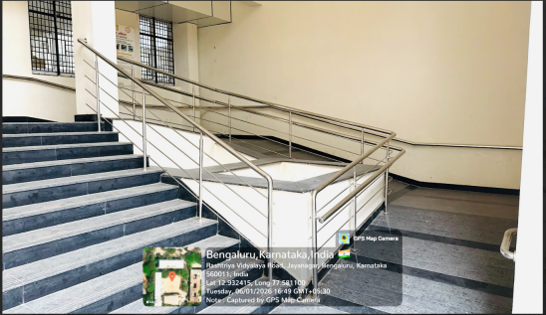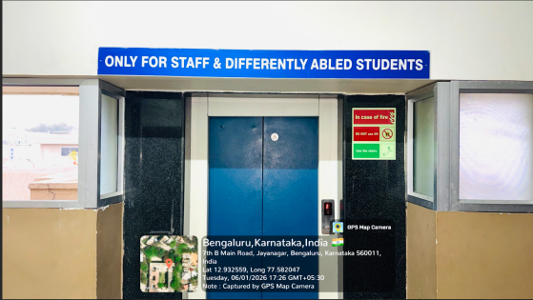

15.viii. Fire and Safety Certificate

15.ix.Hostel Facility
Sl.No | No. of Rooms | Hostel Capacity | Whether Girls Hostel/Boys Hostel | Location
01 | 46 | 110 | Girls Hostel | Outside Campus

15.x Number of Library books/ebooks/Titles/Journals available
BBA
No. of Titles | 1396
No. of Volumes | 7760
No. of Journals published at abroad | 11
No. of e-book Titles-UG | 10
No. of e-book Volumes-UG | 10
Working Hours | 9-6 PM
Name of e-Journal Subscription | DELNET,BC DIGITAL LIBRARY
Total Library area in Sqm | 320
Library Networking | 60
Reprographic Facility | No
No. of Multimedia Pc’s | 5
Reading Room Seating Capacity | 85
Barcode/RFID | Yes
Library Management Software | Yes
BCA
No. of Titles | 228
No. of Volumes | 2982
No. of Journals published at abroad | 11
No. of e-book Titles-UG | 10
No. of e-book Volumes-UG | 10
Working Hours | 9-6 PM
Name of e-Journal Subscription | DELNET,BC DIGITAL LIBRARY
Total Library area in Sqm | 320
Library Networking | 60
Reprographic Facility | No
No. of Multimedia Pc’s | 5
Reading Room Seating Capacity | 85
Barcode/RFID | Yes
Library Management Software | Yes

15.xi.List of online National/International Journals subscribed
15.xii, National Digital Library(NDL) subscription details

- xiii.List of Major Equipment/Facilities in each Laboratory/Workshop
LAB NO. | No. of System | Configuration
LAB-1 | 30 | Device name | DESKTOP-H2KH4O0
 |  | Processor | 13th Gen Intel(R) Core(TM) i5-13420H (2.10 GHz)
 |  | Installed RAM | 8.00 GB (7.70 GB usable)
 |  | Device ID | 4D9031F0-822C-48B0-8103-8707C02D34B0
 |  | Product ID | 00355-61888-35404-AAOEM
 |  | System type | 64-bit operating system, x64-based processor
 |  | Edition | Windows 11 Pro
LAB-2 | 34 | Device name | DESKTOP-GDDSSUE
 |  | Processor | 13th Gen Intel(R) Core(TM) i5-13420H (2.10 GHz)
 |  | Installed RAM | 8.00 GB (7.70 GB usable)
 |  | Device ID | E4207F98-6DAE-4C5D-9690-C2B4CFCCF327
 |  | Product ID | 00355-61661-13285-AAOEM
 |  | System type | 64-bit operating system, x64-based processor
 |  | Edition | Windows 11 Pro
LAB-3 | 30 | Device Model | Lenovo ThinkCentre M710s | Device Model | Lenovo ThinkCentre M700 | Device name |  | ubuntu-ThinkCenter-M710s
 |  | Manufacturer | Lenovo | Manufacturer | Lenovo | Memory |  | 7.7GiB
 |  | Product Number | 10M8S8FV00 | Product Number | 10GSS3TK00 | Processor |  | Intel(R) Core(TM) i3-7100 CPU @ 3.90GHz
 |  | Device Type | Desktop Computer | Device Type | Desktop Computer | Graphics |  | Mesa Intel(R) HD Graphics 630 (KBL GT2)
 |  | Architecture | x86_64 (64-bit) | Architecture | x86_64 (64-bit) | Disk Capacity |  | 500.1 GB
 |  | Processor | Intel Core i5-7500 | Processor | Intel Core i3-6100 | OS Name |  | ubuntu 20.04.5 LTS
 |  | CPU Vendor | Intel | CPU Vendor | Intel | Os Type |  | 64-bit
 |  | CPU Speed | 3.40 GHz (Max 3.80 GHz) | CPU Speed | 3.70 GHz | GNOME Version |  | 3.36.8
 |  | CPU Cores | 4 | CPU Cores | 2 | Windowing System |  | 11
 |  | CPU Threads | 4 | CPU Threads | 4
 |  | CPU Operation Modes | 32-bit, 64-bit | Total CPUs | 4 | WINDOWS (4)
 |  | Motherboard Manufacturer | Lenovo | CPU Operation Modes | 32-bit, 64-bit | Processor |  | Intel(R) Core(TM) i3-10100 CPU @ 3.60GHz (3.60 GHz)
 |  | Motherboard Model | 3102 | Motherboard Manufacturer | Lenovo | Installed RAM |  | 8.00 GB (7.83 GB usable)
 |  | Motherboard Version | SDK0J40697 WIN 3305146019678 | Motherboard Model | 30D9 | Device ID |  | 52913E7B-AAF8-4AC9-97F8-D2DBC652E7C0
 |  | BIOS Vendor | Lenovo | BIOS Vendor | Lenovo | Product ID |  | 00327-36338-89752-AAOEM
 |  | BIOS Version | M16KT51A | BIOS Version | M05KT60A | System type |  | 64-bit operating system, x64-based processor
 |  | BIOS Release Date | 12-07-2018 | BIOS Release Date | 21-07-2016 | Edition |  | Windows 11 Pro
 |  | Firmware Mode | UEFI | Firmware Mode | UEFI
 |  | Installed Memory (RAM) | 8 GB | SMBIOS Version | 3
 |  | SMBIOS Version | 3 | Multiprocessing Support | Enabled (SMP)
 |  | Multiprocessing Support | Enabled (SMP)
LAB-4 | 33 | DELL (10) |  | ThinkPad (15) |  | Acer (8)
 |  | Device Name | DESKTOP-APQVR7V | Device name | DESKTOP-JDEI1UH | Device name |  | DESKTOP-JDEI1UH
 |  | Processor | Intel(R) Core(TM) i7-8700 CPU @ 3.20GHz 3.19 GHz | Processor | 12th Gen Intel(R) Core(TM) i3-12100 (3.30 GHz) | Processor |  | Intel(R) Pentium(R) CPU G3260 @ 3.30GHz, 330 Khz,2 core(s), Logical Pro
 |  | Installed RAM | 16.0 GB (15.8 GB usable) | Installed RAM | 8.00 GB (7.72 GB usable) | Installed RAM |  | 4.0 GB (3.5 GB usable)
 |  | Graphics Card | Intel(R) UHD Graphics 630 (128 MB) | Device ID | 41BB804D-8E2E-4836-8007-B433120D9EAC | Product ID |  | 00268-50195-94081-AAOEM
 |  | Device ID | 85B3BB55-7E18-452B-A07E-D1DEB2B72767 | Product ID | 00330-80844-28499-AA990 | System type |  | 32-bit operating system, x64-based processor
15.xv. .Innovation Cell
Innovation club would help to engage students in innovative and creative activities apart from providing opportunities for hands on activities. The innovation club creates awareness, educate, nurture and inculcate a culture of innovation among students and to enable them to generate new ideas and become more innovative.

Objectives:
- To create awareness, educate, nurture and inculcate a culture of innovation among the engineering student.
- To enable them to generate new ideas and become more innovative.
- To organize Interdisciplinary project exhibition

Roles and Responsibilities:

Enrolment of students as Innovation club member and allow them to work on innovative project.
- Periodic activities, workshops and competitions to keep the spark of creativity, innovation, design alive and thriving in students.
- Guidance for the development of innovative scientific solutions to solve everyday problems.
- To provide technical support in the form of basic tool, shackles, equipment, raw materials and project manual/report.
- To monitor the activities of innovation club.
- To encourage the students to apply for various funds for their innovative projects.

Committee Members:
S No | Name | Actual Designation | Designation in  the Committee
1 | Ms.Anu Revamma | Assistant Professor | Co-ordinator
2 | Dr. Sharada | Assistant Professor | MEMBER
3 | Ms Rochana G | Assistant Professor | MEMBER
4 | Mrs Jyoti Aiyangar R | Assistant Professor | MEMBER
5 | Mrs Pooja V | Assistant Professor | MEMBER
6 | Dr. Mrunalini | Assistant Professor | MEMBER
7 | Dr Megha Dhadothi | Assistant Professor | MEMBER
8 | Dr. Apoorva | Assistant Professor | MEMBER
9 | Mrs Nalina N | Assistant Professor | MEMBER
10 | Dr. Nandhini A | Assistant Professor | MEMBER
11 | Mrs Harshitha. R | Assistant Professor | MEMBER
12 | Mrs Monica R | Assistant Professor | MEMBER

15.vi.Social Media Cell
NMKRV College has a well-established Media Cell that has been functioning effectively for the past many years.
The Media Cell plays a key role in documenting and promoting institutional activities.
It provides students with hands-on exposure to media, communication, and creative skills.
The cell supports the coverage of academic, cultural, and co-curricular events.
Students are trained in content creation, photography, videography, and editing.
The Media Cell also contributes to branding and outreach of the institution.
It encourages student participation and nurtures creativity and teamwork.
Faculty members guide students in maintaining professional media standards.
The long-standing presence of the Media Cell reflects institutional consistency and innovation.
Overall, it strengthens communication, visibility, and student skill development at NMKRV College.
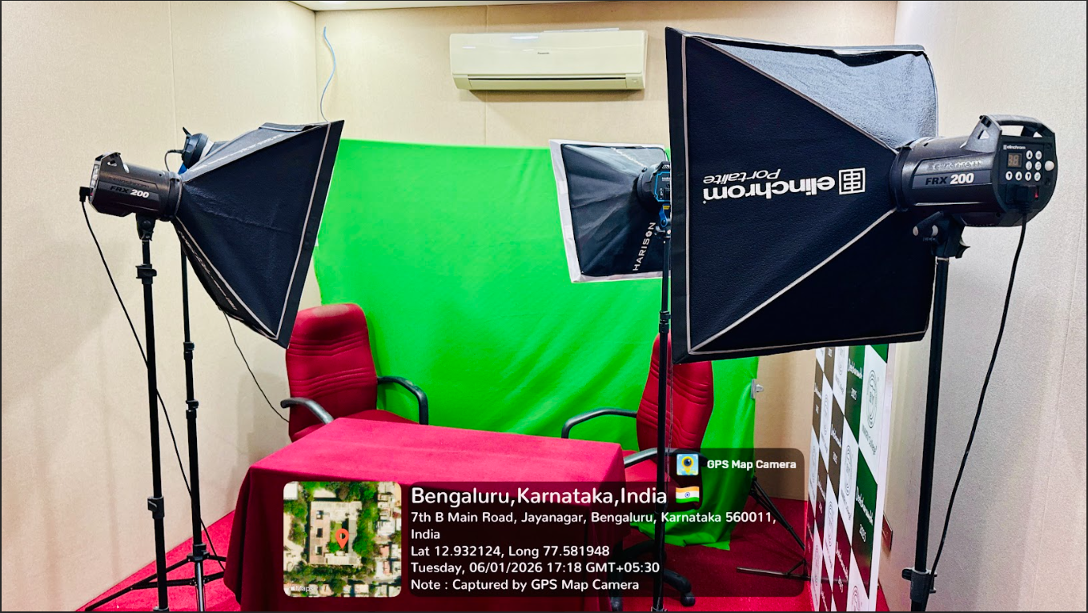
15.vii. Compliance of the Academic Bank of Credit(ABC) applicable to PGDM/PGDM Institutions and University Departments- Not Applicable
15.xviii. To upload the respective short video of Infrastructure and facilities available w.r.f the course in the website.
- xix. Games and Sports Facilities

Sports is an Integral part of the curriculum in our college. Our college is proud of producing quality Sports personalities, who have represented the Karnataka state, University and India in several games.
The college campus of 41/2 acres of land has adequate space for a playground and other sports related activities. The college also has Outdoor and Indoor Sports area and other such facilities like Gymnasium.
- Size of the ground - 176’0’’ x 165’0’’ - 29040 sqft
- Indoor Sports hall - 32’0’’ x 66’0’’ - 2112 sqft
-31’6’’ x 32’0’’ - 1008 sqft
Outdoor Sports facilities
- Throw ball
- Volley ball
- Ball Badminton
- Kho- Kho
- Kabaddi
- Football
- Cricket
- Basket ball
Indoor Sports Facilities
- Table Tennis
- Carrom
- Chess
- 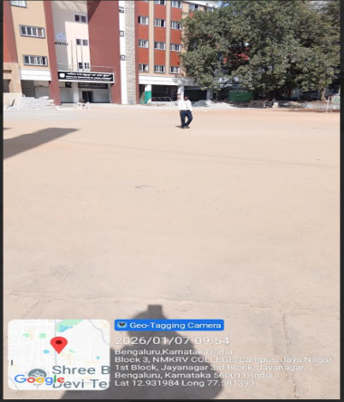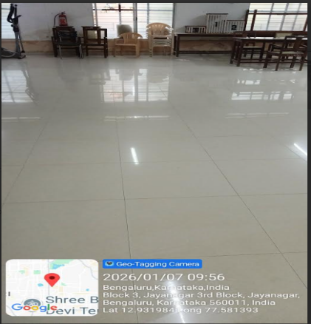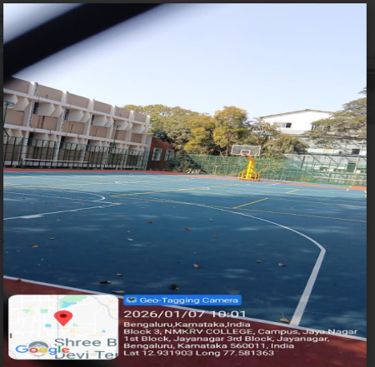

- xx.Teaching Learning Process-syllabus
S.No | Course | Syllabus
1 | BBA | https://drive.google.com/file/d/14VCiIPHaTvao9dmzpic7lQ8V5HAQVjxI/view?usp=sharing
2 | BCA | https://drive.google.com/file/d/1_v-ZWBMbxj5qq82U9uHhmFZaEa7joBDW/view?usp=sharing

15.xxi Foe each Post Graduate Courses give the following- Not Applicable
16 Enrolment and placement details of students in the last 3 years
2021-2022
Name of student placed with his/her contact details | Programme completed | Name of the employer with contact details | Pay package at the time of appointment
Sogra Fathima Ahmed | BBA | Axis Bank | 200000 LPA + Attractive Incentive + PF + ESIC
Akshitha M Parihar | BBA | WELLS FARGO iPRIMED | INR 3.2 Lakhs
Ridhi Gupta | BBA | WELLS FARGO iPRIMED | INR 3.2 Lakhs
Akshitha M Parihar | BBA | Capgemini GTT | 2.4 LPA
Heena Kauser | BBA | Capgemini GTT | 2.4 LPA
Nafisa Fathima I | BBA | Capgemini GTT | 2.4 LPA
Payal Kumari rawal | BBA | Capgemini GTT | 2.4 LPA
PRATHAMA K RAO | BBA | Capgemini GTT | 2.4 LPA
Rachana kiran | BBA | Capgemini GTT | 2.4 LPA
Tabassum Taj | BBA | Capgemini GTT | 2.4 LPA
TAHSEENA SYEDA | BBA | Capgemini GTT | 2.4 LPA

Placement Statistics 2022
Sl.No | Name of student placed | Programme completed | Name of the employer | Pay package at the time of appointment
8 | Sogra Fathima Ahmed | BBA | Axis Bank | 200000 LPA + Attractive Incentive + PF + ESIC
100 | Akshitha M Parihar | BBA | WELLS FARGO iPRIMED | INR 3.2 Lakhs
157 | Ridhi Gupta | BBA | WELLS FARGO iPRIMED | INR 3.2 Lakhs
165 | Akshitha M Parihar | BBA | Capgemini GTT | 2.4 LPA
187 | Heena Kauser | BBA | Capgemini GTT | 2.4 LPA
201 | Nafisa Fathima I | BBA | Capgemini GTT | 2.4 LPA
209 | Payal Kumari rawal | BBA | Capgemini GTT | 2.4 LPA
210 | PRATHAMA K RAO | BBA | Capgemini GTT | 2.4 LPA
213 | Rachana kiran | BBA | Capgemini GTT | 2.4 LPA
231 | Tabassum Taj | BBA | Capgemini GTT | 2.4 LPA
232 | TAHSEENA SYEDA | BBA | Capgemini GTT | 2.4 LPA
2023-24
Sl. No | Name of the Company | Job Role Offered | Paypackage CTC | Number of Students Shortlisted
1 | Accenture | Packaged APP Development Associate | 3- 3.5 LPA | 19
2 | TCS | Traineeship | 2.8-3.5 LPA | 28
3 | Airtel | Relationship Manager | 5 LPA | 11
4 | Deloitte | Advisory Associate Analyst | 3.25 LPA | 3
5 | Q- Spiders | Incubation Program | 2.5-3 LPA | 26
6 | Oriyan Groups (Banashankari) | Business Development Executive | 2.8- 3.1 LPA | 20
7 | Piramal Finance | DST Sales Trainee | 2,74,000 | 16
8 | Codeyang | Marketing Executive | 4.36 LPA | 10
9 | Equatas | Relationship Manager | 2.5LPA | 19
10 | Quess Corp | Cash Management | 2.8 LPA | 23
11 | Orayan Group of Companies (Jayanagar) | Business Development Executive | 2.8- 3.1 LPA | 16
12 | Muthoot | Probationary Officer | 3-3.8 LPA | 28
13 | Ezy Ventures | HR Interns | 2.5- 3 LPA | 36
14 | RM Associates | Trainer | 2.5- 3 LPA | 5
15 | HRH | Relationship Manager | 2.5- 3 LPA | 6
16 | Sambhav Foundations | Trainer | 2.5-3. LPA | 10
17 | Axis Bank | Relationship Manager | 2.8 LPA | 5
18 | Bandhan Bank | Relationship Manager | 3LPA | 4
 |  |  |  | 285

2024-2025
Sl. No | Name | Course | Company | CTC (INR)
87 | Vidya Shree M | BCA | Nivara Housing Finance | 3,20,000
102 | Spurthi P Jain | BCA | Nivara Housing Finance | 3,20,000
111 | Thanushree M | BCA | Nivara Housing Finance | 3,20,000
121 | Myyhri S | BCA | Nivara Housing Finance | 3,20,000
124 | Sandhya M | BCA | Nivara Housing Finance | 3,20,000
127 | Siva Ranjini | BCA | Nivara Housing Finance | 3,20,000
129 | Akshaya.R | BCA | Nivara Housing Finance | 3,20,000
132 | Sinchana K S | BCA | Nivara Housing Finance | 3,20,000
140 | Koneti Nandini | BCA | Nivara Housing Finance | 3,20,000
160 | PALLAVI | BBA | GR Management Solutions | 3,40,000
161 | ANUSHA K V | BBA | GR Management Solutions | 3,40,000
162 | ANUSHA R | BBA | GR Management Solutions | 3,40,000
163 | NALINI | BBA | GR Management Solutions | 3,40,000
164 | NAVANDHANA | BBA | GR Management Solutions | 3,40,000
188 | SAI ADITHI MA | BBA | HR Spectrum | 3,18,000
189 | SHARANYA V R | BBA | HR Spectrum | 3,18,000
190 | ARATHI | BBA | HR Spectrum | 3,18,000
221 | Kavya Shree J | BBA | Airtel | 3,27,000
222 | Samyuktha M | BBA | Airtel | 3,27,000
223 | S Angu Divya | BBA | Airtel | 3,27,000
224 | R Tejashree | BBA | Airtel

17. List of research Projects/Consultancy Works
18. MoUs with Industries
https://drive.google.com/file/d/1GTNUv9zgLTQ2BOAErWZ1dqZVwE4ybryV/view?usp=sharing

